1.5.1:
<table border="1">
<tr>
<td>row 1, cell 1</td>
<td>row 1, cell 2</td>
</tr>
<tr>
<td>row 2, cell 1</td>
<td>row 2, cell 2</td>
</tr>
</table>

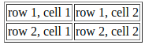

1.5.2:
<table border="1">
<tr>
<td>Row 1, cell 1</td>
<td>Row 1, cell 2</td>
</tr>
</table>
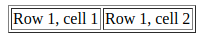

1.5.3:
<table border="1">
<tr>
<th>Heading</th>
<th>Another Heading</th>
</tr>
<tr>
<td>row 1, cell 1</td>
<td>row 1, cell 2</td>
</tr>
<tr>
<td>row 2, cell 1</td>
<td>row 2, cell 2</td>
</tr>
</table>
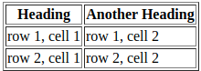

1.5.4:
<table border="1">
<tr>
<td>row 1, cell 1</td>
<td>row 1, cell 2</td>
</tr>
<tr>
<td>row 2, cell 1</td>
<td></td>
</tr>
</table>
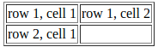

<table border="1">
<tr>
<td>row 1, cell 1</td>
<td>row 1, cell 2</td>
</tr>
<tr>
<td>row 2, cell 1</td>
<td>&nbsp</td>
</tr>
</table>

1.6.2:

<html>
<body style="background-color:PowderBlue;">
<h1>Look! Styles and colors

</h1>
<p style="font-family:verdana;color:red">
This text is in Verdana and red
</p>
<p style="font-family:times;color:green">
This text is in Times and green
</p>
<p style="font-size:30px">
This text is 30 pixels high
</p>
</body>
</html>

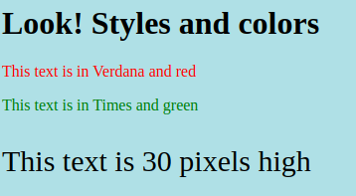

1.7.1:

<ul>
<li>Coffee</li>
<li>Milk</li>
</ul>
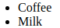

1.7.2:
<ol>
<li>Coffee</li>
<li>Milk</li>
</l>
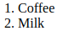

1.7.3:
<dl>
<dt>Coffee</dt>
<dd>Black hot drink</dd>
<dt>Milk</dt>
<dd>White cold drink</dd>
</dl>

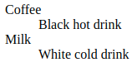

1.8.3:
<q> Here is a short quotation here is a short quotation </q>
<blockquote>
Here is a long quotation here is a long quotation
here is a long quotation here is a long quotation
here is a long quotation here is a long quotation
here is a long quotation here is a long quotation
here is a long quotation.
</blockquote>

